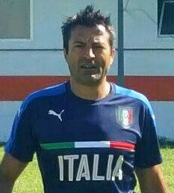Cognome: Lugnan

Nome: Luca

Mail: [luca@lugnan.it](mailto:luca@lugnan.it)

Sito: [www.lugnan.it](http://www.lugnan.it)

Certifications:

* March 2016 Master UEFA A PRO
* July 2013 update stage on youth team Inter FC
* September 2011 update stage on ball possession and position game of Barcelona FC
* February 2010 update stage on ball possession of Ajax
* Certificate at Juventus Accademy Soccer School (top certification)
* 2006/2007 Observer for ACF Fiorentina
* 2004/2008 Coordinator of Summer Camp for ACF Fiorentina and Genoa CFC

Coach career:

* 2016 coach for first team of ISG Gradisca
* 2014/2015 coach youth team of U17 Ancona (keep first regional position)
* 20010/2014 coach first team of Marzanese
* 2009/2010 coach youth team of U17 Moiacco
* 2006/2009 assistant first team coach for Portogruaro cat. Lega Pro

I’m Luca Lugnan professional coach UEFA A PRO, certificate got at trainer center of Coverciano, Florence. I’m a good looking and strong personality person with a high management skills. These skills combined with a long experience in the football sector and a very reliable character make me an ambitious coach who aspire to work at a high international level.